SOCIAL MEDIA RECRUITING ASSISTANT TRAINING

**OUTLINE**

* Welcome to the Team
* Micro Influencer Training
  + Social Media Kick-Off
  + Role & Responsibilities
  + Importance of Organic Recruits
  + Driving Social Media Engagement
* Receptionist Training (if applicable)
  + Calling Excellence

**MICRO INFLUENCER TRAINING**

Welcome to the Team (20 mins)

* Signing In
* Introductions and Ice Breaker
* Welcome to the Team
  + *Who are we? What do we do? Why do we do it?*
    - *What do we sell? How do we sell it?*
  + *Who are our key players?* 
    - *How has the opportunity improved their professional & personal lives?*
* Share office goals and vision with confidence and high-energy
  + Our reps sell ______, you sell the opportunity that comes with the sales position. With your help, we can bring additional value to the community.
* **BEST PRACTICE**: Invite top 1-2 sales reps to come into the office for live testimonials

Debrief (10 mins)

Takeaways and lightbulbs?

* + *Group discussion*
* We covered how the opportunity has helped others. I want you to think about what you’re most excited to gain from the experience. We spoke about it briefly in your interview so take a second to think through it now.
  + *Individual Debrief.*

Social Media Kick-Off (15 mins)

* We’re going to prep your first post now so at the end of training we can review how to answer the most common questions you’ll receive.
* Listen closely… we will post this then we’ll put your phone off to the side! Do not check responses yet because we haven’t gone through how to properly describe the position. Make sense?
* Let’s get the creative juices flowing!
  + *Share examples of previous posts from the team.*
* The only requirements for the post are that you (1) tag (Manager) and (2) include 2-3 key job features.
  + Here are the features you could highlight. *Insert your most marketable job features… could be pay, mentorship, professional development, fun work environment, etc.*
* The rest is up to you! You know your following better than we do. Think back to which of your story posts got the most engagement.
  + Maybe it was aesthetic, funny, or a combination of the two. Maybe you get more engagement on videos vs. pictures or original posts vs. reposts.
  + *Alternative: Have pre-made content already to post as is.*
* Once you’re done, let me take a peek. Once you’ve posted, put your phone to the side. We’ll come back to this later.
* **BEST PRACTICE**: Make this fun by encouraging creativity and welcoming feedback!

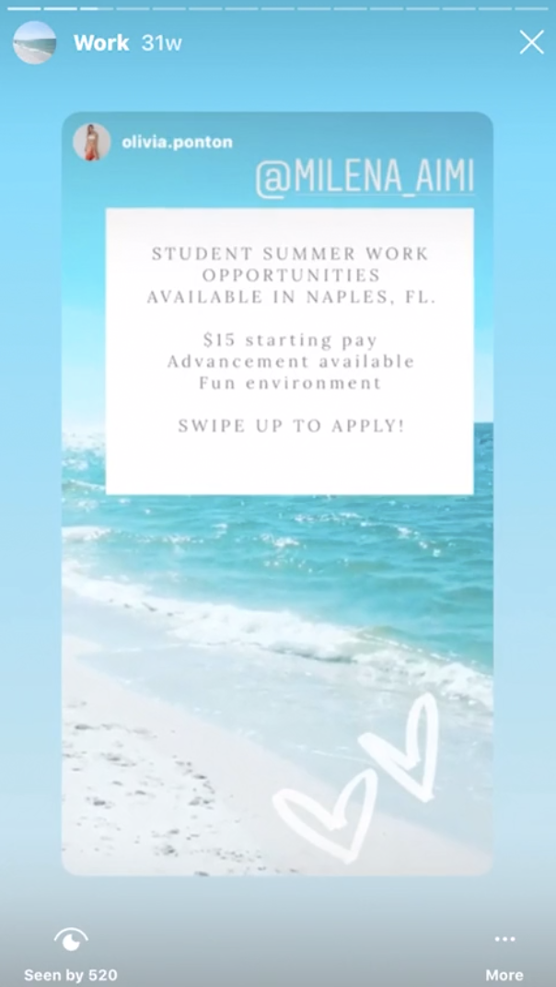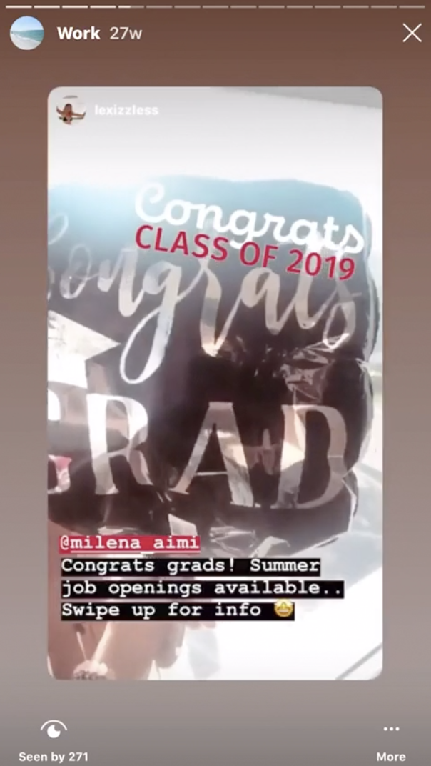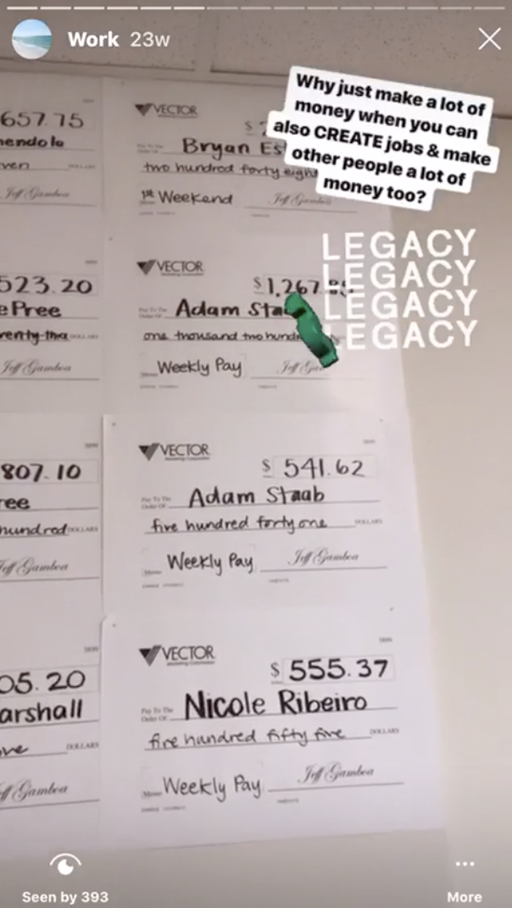

Role & Responsibilities (15 mins)

* Your role is arguably the most important in ensuring our business hits our goals. Without you, we can’t build a high-caliber sales team. You’re the face of the business as you market the opportunity.
* We know the job isn’t for everyone, but everyone deserves to know the opportunity is available! We want to market the role to ensure everyone is at least aware of the opportunity.
  + If I say soda/pop… what comes to mind first? Coca-Cola?
  + Does anyone know why Coca-Cola costs more than Winn-Dixie Cola?
    - Branding… You can’t go more than two days without seeing an ad for coca-cola sodas. But does every person that sees the ad buy a can of Coke?
    - No, but when they’re thirsty for a sugary drink what is the first thing that pops to mind?
* We have traditional ads, we’re on social media, we’re on indeed, our current sales reps recommend their friends.. we give them incentives to do so, by the way. Not everyone that sees our ads or hears about us looks into the opportunity. And not everyone that does, gets an interview with us or gets accepted.
* Advertising and branding works like a funnel. We may not have control over what makes it through the funnel but we can control how much goes into the funnel to start.
  + This is why your role is so important.
* Here is what your shifts will look like…. *Rule Book Handout*
  + *Review objective of each shift, shift options, and clocking in*
* After your first 2-3 weeks we’ll have a 1-on-1 to analyze your performance with social media work (if applicable) and the receptionist side of the role.
  + We’d simply have an open conversation regarding your strengths and interests. By then, you’d be eligible for our sales program.
  + You have the opportunity to experience three different roles and add diversity to your resume!
* Provide examples of success stories… If possible, have your key players pop in for a live testimonials.
  + *Melyssa (Boca Raton) ended up selling 20k+ the summer she started and made extra $5k+ in income… decided she loved developing her sales skills and spends most of her time selling as she remains involved with social media work*
  + *Nicole (Miami) started as a SMRA and ended up selling $10k+ so she made extra $2k in income… decided she enjoys social media work more so she is now in charge of the SMRA program down in Miami where she handles all recruiting and training of new hires. She still sells sporadically on the side to have dual source of income*
  + *Kasey (Ft. Lauderdale) did it backwards and actually started with the sales role but was interested in developing her social media experience since she is going into Sports Management so she is now the head receptionist & Recruiting Manager in charge of running some our sales representative group interviews*
* Any questions?

Importance of Organic Recruits (20 mins)

* We’ll teach you how to market, first through your social and personal networks… Couple of you mentioned in the interview you have people you want to personally recommend.
* Now that you have more clarity on the sales position, you’ll be able to recommend whoever you think would be a great addition to our team.
  + Then we’ll reach out to connect and tell them more about the opportunity.
  + If they’re not interested, no harm no foul. Now they at least know about the position for future reference or can even recommend it to another friend!
* We’re going to put together a list of your Top 10-20 friends you think would do well with the job. This will be a living document… meaning we will update it as we go, add more people, and move people from top of the list to bottom or vice versa.

**BEST PRACTICE**: Have google sheet ready to go! Drive brainstorming sessions by providing additional ideas and managing objections as they arise.

* On the google sheet I shared with you… you’ll see a tab at the bottom with your name. Pull out your phone contacts and just scroll through.. I’ll give you guys some ideas:
  + Business minded
  + Super personable
  + Great team player (athlete)
  + Strong work ethic
  + Growth oriented
  + Super funny
  + Really great student
  + Needs help with their resume
  + Needs money
  + Needs a positive environment

Once you have your top 10-20…

**Option A**: Send everyone a head’s up text so they expect our call!

* *Hey!! Hope all is well. Just a head’s up I gave your number to my manager. We have some positions we are trying to fill for the summer… thought of you! Just thought you would do super well. She/he is going to reach out with the details so definitely hear her/him out, thank you!*

**Option B**: start a 3-way text with me & send them this:

* *Hey ____, I wanted to introduce you to my manager. I think you’d be a great fit for an opening we have on our team. They’ll give you all the details. Good luck!*
* Manager to respond: “Thanks for the intro (SMRA)! (PR), I would love to connect. Will you be available to chat if we reach out between ___ and ____?

***Option C:*** Alley Oop

* *Call friend directly from SMRA’s phone*

Driving Social Media Engagement

* Now we’re going to respond to your responses on social media from your earlier posts and send out a few outgoing messages so we can get used to your shift tracking sheet.
  + *SMRA Message Approach to Sales Rep HO*

**BEST PRACTICE**: Prep them for some potentially negative responses… better safe than sorry. People are quick to blame others for their own lack of effort, I have been guilty myself. I have NEVER worked with someone who followed the program and worked hard, who didn’t succeed with us!

Wrap Up

* Congratulations!
* Review schedule and assignments for next shift
  + Top 20 List finalized
  + Updated IG responses
* **BEST PRACTICE**: Ensure first shift 1-3 days after training

**RECEPTIONIST TRAINING**

The 5 Basics (17 mins)

* *The 5 Basics HO*
* Walkthrough Video
  + <https://drive.google.com/open?id=1jJN4PqCrH5zTgnSHnpSNleJDDYsFHbem>

Approach Walk Through (17 mins)

* *PR Approach HO*
  + <https://drive.google.com/open?id=1UetNpifc7CWi601bVDJQPZrHCuydm5ez>
* Manager to use:
  + *PR Approach - Why’s of the Approach HO*

Objections Walk Through (10 mins)

* *Objections HO*

Debrief (5 mins)

* Any questions?
* Debrief

Role play (20 mins)